A000-AM,C-Taino-Ceremonial Celt-Steatite-1000 CE

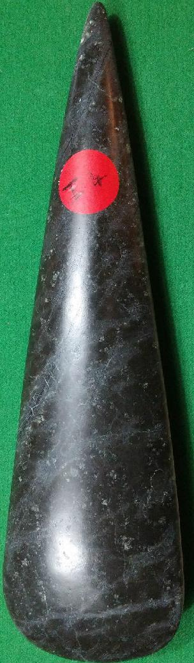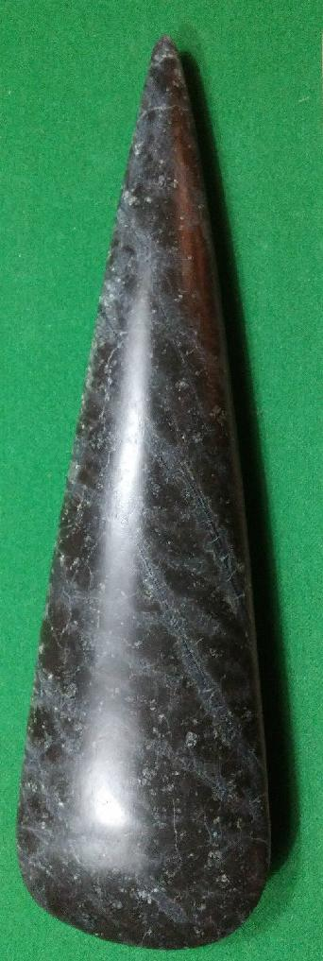

AM,C-Taino-Ceremonial Celt-Steatite-1000 CE

Case No.: 18

**Accession No.**

**Formal Label:** AM,C-Taino-Ceremonial Celt-Steatite-1000 CE

**Display Description:**

Ceremonial celts of a petuloid shape without an attached figure are highly polished of local metamorphic stone. They may have mythic significance as a celt was used to free mother tortoise, the progenitor of Mankind. They were also used for ceremonial purposes, as none have marks of use-wear. Since they were large, some, like this example, being over a foot in length, were presumably intended for élite consumption. The distribution of highly polished celts extends from the Bahamas to Trinidad, suggesting a sophisticated system of trade and exchange of élite ceremonial objects among caciques in efforts to establish alliances or exchange of such objects as means of currency (Roberts 2014: 163).

**LC Classification:**

**Date or Time Horizon:**

**Geographical Area:** from the Dominican Republic

**Map:**

**GPS coordinates:**

**Cultural Affiliation:**

**Media:**

**Dimensions:** Length: 12 3/16 in.

**Weight:**

**Condition:**

**Provenance:** from the Dominican Republic

**Discussion:**

**References:**

# Roberts, Larry. 2014. *Taino Sculpture: art of the gods* (Micanopy, Florida: Signature Book Printing)

# 